XRD Phase Finder: iterative residual scoring for powder diffraction identification
A. B. Kuznetsov
Sobolev Institute of Geology and Mineralogy, Siberian Branch of the Russian Academy of Sciences, Novosibirsk 630090, Russian Federation
Correspondence: ku.artemy@igm.nsc.ru
Open desktop software supports automatic and semi-automatic interpretation of crystalline phases in powder mixtures using several structure sources, user CIF files, global Match ranking and staged Gain scoring.
XRD Phase Finder is an open-source desktop application for automatic and semi-automatic interpretation of the crystalline phases present in powder mixtures. Automatic search generates and ranks a candidate list, whereas the semi-automatic workflow allows the user to set elemental constraints, inspect the diffraction evidence and accept phases between search iterations. The program searches user-accessible records from the Crystallography Open Database, Materials Project, AFLOW, OQMD and RRUFF, and it can evaluate an individual CIF file without adding it to a database. Candidate patterns are calculated locally and displayed with the experimental profile, reflection markers, background components and unexplained lines. Match ranks initial candidates by two-way agreement between their strongest reflections and the strongest experimental line records. After one or more phases have been accepted and jointly fitted, Gain ranks remaining candidates by statistically supported diffraction evidence that is not adequately explained by the accepted model. Smoothing, physical-background estimation and an optional broad amorphous contribution remain inspectable and reversible. For accepted phases, normalized non-negative fitted profile contributions provide a semi-quantitative estimate. Projects retain imported patterns, processing settings, accepted phases and view state. Standalone Windows and macOS packages are distributed under the MIT licence. Match and Gain are ranking scores rather than phase probabilities, and the semi-quantitative values are not validated mass fractions.
powder X-ray diffraction; phase identification; search–match; residual scoring; open crystallographic databases; graphical user interface; multiphase analysis
- Introduction
Powder X-ray diffraction (PXRD) remains one of the most widely used experimental techniques for phase identification and crystal-structure characterization because sample preparation is comparatively simple and the method is applicable to a broad range of crystalline materials (Dinnebier & Billinge, 2008). Beyond phase identification, PXRD is routinely used to determine lattice parameters, crystallite size, microstrain, preferred orientation and quantitative phase composition. Real laboratory patterns nevertheless remain difficult to interpret: peaks overlap, relative intensities are affected by preferred orientation and microabsorption, lattice parameters vary with composition, poorly crystalline components broaden, and instrumental or amorphous contributions distort the slowly varying signal.
Software used with powder diffraction data can be divided broadly into search–match systems, profile and structure-refinement packages, and crystal-structure visualization tools. Search–match applications include the commercial programs Match! (Putz & Brandenburg, 2024), HighScore (Degen et al., 2014), JADE (International Centre for Diffraction Data, 2026), DIFFRAC.EVA (Bruker, 2026) and STOE SEARCH/MATCH 2 (STOE & Cie GmbH, 2026). Refinement-oriented packages include GSAS-II (Toby & Von Dreele, 2013), FullProf (Rodríguez-Carvajal, 1993) and TOPAS (Coelho, 2018), whereas VESTA (Momma & Izumi, 2011) and Mercury (Macrae et al., 2008) are primarily used for structure visualization and crystallographic inspection. These categories overlap, but their principal tasks remain different: rapid candidate identification, quantitative profile modelling, or visualization.
Open crystallographic resources have substantially lowered the barrier to reproducible phase-identification workflows. The Crystallography Open Database (COD) provides published experimental crystal structures (Gražulis et al., 2009; Gražulis et al., 2012). Materials Project (Jain et al., 2013), AFLOW (Curtarolo et al., 2012) and OQMD (Saal et al., 2013) provide large collections of computational structures, whereas RRUFF supplies mineral-oriented experimental data and crystal structures (Lafuente et al., 2015). Open libraries including Gemmi (Wojdyr, 2022), pymatgen (Ong et al., 2013), spglib (Togo et al., 2024) and the Atomic Simulation Environment (Larsen et al., 2017) provide standard operations for reading CIF files, handling structures and applying crystallographic symmetry.
Several existing programs already connect these resources to phase identification. QUALX2.0 combines peak-based search–match with the freely available POW_COD database and automated preprocessing (Altomare et al., 2015). iQual uses an indexed COD-derived database and a two-stage search strategy (Lv et al., 2024). Full-profile search–match tests candidate structures by iterative Rietveld fitting (Lutterotti et al., 2019), and FullProfAPP provides a graphical automation layer for this workflow (Arcelus et al., 2024). XMatcher provides an open framework based on chemical constraints, angular-shift correction, one-to-one peak matching and peak-level evidence (Cao, 2026). Commercial systems also support residual or iterative workflows: notably, DIFFRAC.EVA 8 introduces Profile Fit Residual Search, in which accepted phases are fitted and unexplained residual regions are searched again (Bruker, 2026). Therefore, neither access to COD nor residual-guided phase search alone should be presented as unique.
In practice, an open workflow still often involves separate database searches, downloaded structures, pattern calculations and comparison tools. XRD Phase Finder brings these steps into one cross-platform workspace. It searches several open structure sources, accepts user CIF files, builds local indexes, compares profiles interactively and saves the analysis as a project. The ranking answers two different questions. Match asks whether a candidate agrees with the experimental line set as a whole. Gain asks what that candidate adds to the phase model already accepted by the user, including signal hidden beneath an incompletely fitted shared reflection. This separation keeps the reasoning in a multiphase search visible to the user.
The following sections describe the software architecture, diffraction calculation, Match and Gain algorithms, and the validation used in this work. XRD Phase Finder is intended for automatic and semi-automatic interpretation of the crystalline phases present in powder mixtures.
- Materials and methods
  - Software architecture and distribution
XRD Phase Finder version 1.2.2 is implemented in Python 3.11–3.12. The graphical interface uses PySide6 (The Qt Company, 2026); numerical operations use NumPy (Harris et al., 2020) and SciPy (Virtanen et al., 2020); tabular data handling uses pandas (McKinney, 2010); plotting uses Matplotlib (Hunter, 2007); and crystallographic information is read with Gemmi (Wojdyr, 2022). The program separates data models, file input, crystallographic services, candidate retrieval, scoring and graphical controllers. Computational modules contain no Qt dependencies. A CalculationContext stores the wavelength, profile width, zero shift, cell scale and calculation grid as an immutable description of a calculation. This context is also used to form reproducible cache keys.
Calculated reflection lists and profiles are cached in memory with bounded least-recently-used behaviour, and local database metadata and derived peak records are indexed in SQLite. Repeated previews therefore reuse CIF-to-reflection and reflection-to-profile results when the relevant calculation context has not changed. Standalone installers are provided separately for Windows and macOS. User settings, project files and database caches are stored outside the installed application so that program updates do not replace user data.
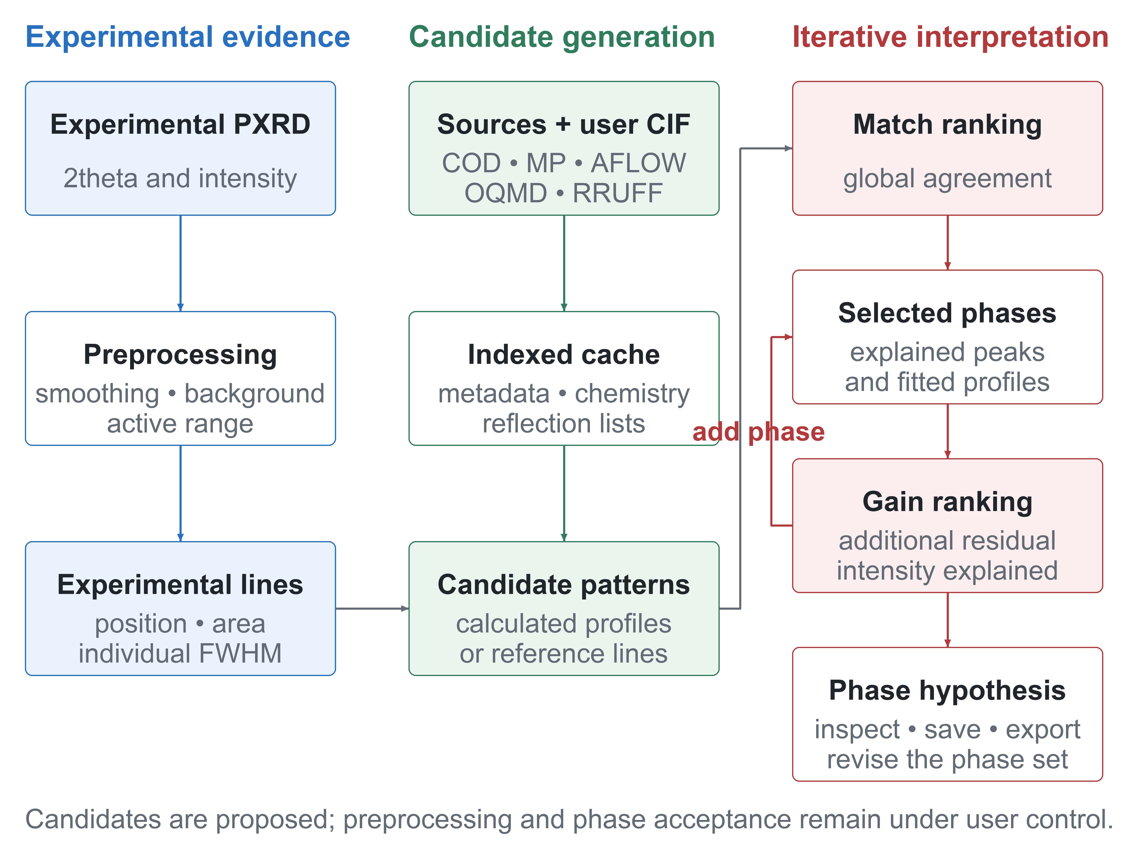
- Operational workflow of XRD Phase Finder. Experimental data and optional chemical constraints define a candidate pool assembled from open resources or user CIF files. Match ranks global agreement. Accepted phase profiles are fitted jointly with non-negative coefficients, and staged Gain re-ranks remaining candidates using uncovered, overlapping and hidden-phase evidence. At every stage the user can inspect and revise the phase model.
  - Input data, preprocessing and analysis state
Experimental patterns are imported from common two-column text representations containing diffraction angle and intensity. The original values are retained. Smoothing and background handling are explicit, reversible analysis operations rather than hidden destructive transformations. The interface can display the original profile, a smoothed profile, an estimated physical background, and a combined background plus broad amorphous contribution. The latter two components can be inspected before subtraction. This distinction is important because diffuse scattering and broad nanocrystalline peaks are sample information, whereas instrumental and holder contributions are nuisance signals.
Automatic settings select parameters for existing smoothing and background models; they do not replace the numerical algorithms with an opaque classifier. The user may reject the proposed processing and adjust the parameters manually. For scoring, the program uses the active processed representation and records whether background removal has been applied. Project files preserve imported patterns, their ordering, selected phases, processing settings, view settings and relevant phase-assignment state.
The program provides extended smoothing and background-estimation options. Smoothing includes moving-average and Gaussian filters and the Savitzky–Golay method (Savitzky & Golay, 1964). Available background models include asymmetric least squares (AsLS) (Eilers & Boelens, 2005), asymmetrically reweighted penalized least squares (arPLS) (Baek et al., 2015), SNIP (Morháč et al., 1997), rolling-ball processing through pybaselines (Erb, 2022), and robust one-, two- or three-exponential models selected with the Bayesian information criterion (Schwarz, 1978). The background can be estimated alone or together with a broad amorphous-phase contribution. The physical background and the combined background-plus-amorphous curve are shown separately; their difference provides an estimate of the broad amorphous contribution. Each component can be inspected, applied or subtracted under user control.
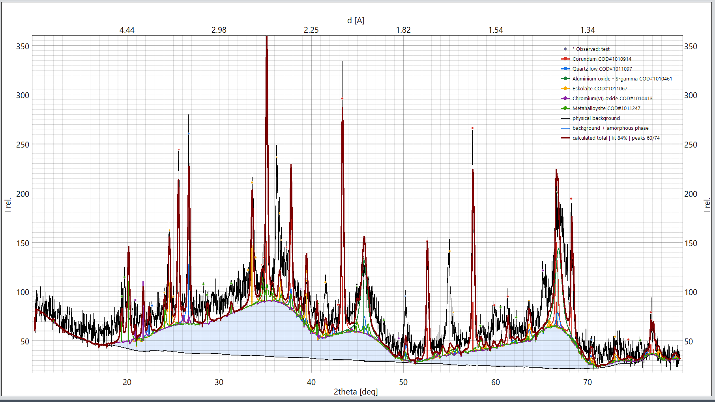
- Inspectable separation of slowly varying background and broad amorphous scattering. The physical background and the combined background-plus-amorphous estimate are displayed independently; the area between them represents the estimated broad amorphous contribution. No component is subtracted until the user applies the selected operation.
  - Open data sources and direct CIF input
The candidate layer deliberately distinguishes experimental reference evidence from structures used to calculate a theoretical pattern. COD contains published experimental crystal structures (Gražulis et al., 2009; Gražulis et al., 2012). Materials Project, AFLOW and OQMD primarily contribute computational structures (Jain et al., 2013; Curtarolo et al., 2012; Saal et al., 2013). RRUFF contributes mineral-oriented experimental data and structures (Lafuente et al., 2015). A valid CIF can also be added directly, which allows a laboratory reference, a newly refined structure or a phase absent from the integrated services to be evaluated without modifying a global database.
- Open data sources available to XRD Phase Finder.
Source | Primary content | Role in the program | Important interpretation
COD [2,3] | Published experimental crystal structures | Structure retrieval and calculated PXRD patterns | Open structure collection; calculated patterns are not certified reference measurements
Materials Project [14] | First-principles structures | Candidate generation and calculated patterns | Computational structures; agreement must be verified against experiment
AFLOW [15] | First-principles structures | Candidate generation and calculated patterns | Computational structures
OQMD [16] | First-principles structures | Candidate generation and calculated patterns | Computational structures
RRUFF [17] | Experimental mineral data and structures | Mineral-oriented reference evidence | Coverage is domain-specific
User CIF | Any valid local CIF supplied by the user | Direct comparison and private/reference libraries | Allows phases absent from integrated sources to be tested

Chemical-element filters restrict the initial candidate pool but are not treated as proof of phase presence. Source and entry identifiers are retained together to prevent collisions between databases, and each displayed candidate remains linked to a source record or local CIF. Large third-party collections are not embedded in the platform installers. The program can query supported online resources, reuse persistent local SQLite/CIF indexes and evaluate user-supplied CIF files directly. Search coverage therefore depends on the connected services and the local database snapshot available for a run. Absence from a compact local subset is a coverage limitation, not evidence that a phase is absent from the specimen.
  - Calculation of candidate patterns
For a structure-based candidate, symmetry-expanded atomic positions, unit-cell parameters and the selected wavelength are used to calculate reflection positions and relative intensities. The calculation follows standard powder-diffraction relations: Bragg positions, structure-factor summation with Cromer–Mann atomic scattering factors (Cromer & Mann, 1968), multiplicity and displacement terms, and a Lorentz–polarization correction consistent with standard tabulations (Gilmore et al., 2019). Reflection sticks can be broadened into a pseudo-Voigt profile (Thompson et al., 1987). Profile contributions are evaluated only in a finite interval around each reflection, avoiding full-grid evaluation for points where the contribution is negligible. Kα2 can be included when appropriate. Candidate sticks, broadened profiles and the experimental signal are displayed on a shared angular scale; optional global zero and small scale corrections are used for ranking but are reported as alignment aids, not as refined crystallographic parameters.
  - Observed peak detection
Observed diffraction maxima are converted into experimental line records rather than used only as peak positions. Each record stores the observed 2theta position, a prominence-derived integrated line area and an individual experimental FWHM estimated with the SciPy peak-width routine (Virtanen et al., 2020). The width is used as the local matching window for deciding whether a calculated stick line is supported or whether an observed line has already been explained by selected phases. This line-record representation reduces the dependence of the ranking step on an assumed calculated profile width; broad and narrow experimental peaks can therefore be treated with different tolerances in the same pattern. Candidate ranking uses up to 80 observed line records, while the strongest calculated reflections form the main candidate-side evidence. The minimum peak separation corresponds to approximately 0.11 deg 2theta and the accepted detected width is bounded to suppress isolated noise and excessively broad baseline features. These defaults are pragmatic search settings and should be reported with benchmark results.
  - Match: global candidate compatibility
Match is a global stick-line compatibility score. For each candidate, the strongest calculated reflections are compared with the strongest experimental line records rather than with every point of a broadened synthetic profile. A bounded scale in sin(theta) is estimated from clusters of direct line coincidences, allowing small systematic angular differences without treating them as a refined unit cell. The aligned comparison is bidirectional: observed-anchor coverage asks whether the candidate explains the strongest experimental lines, whereas candidate-line coverage asks whether the candidate's own strong reflections are supported by the experiment. Position agreement is evaluated with a narrow central plateau and a linearly decreasing tolerance, and relative-intensity agreement moderates each line match.
M = 100 [0.62 Cobs + 0.25 Cref + 0.08 Ccount + 0.05 Cseed].
Here Cobs is the intensity-weighted coverage of the leading observed anchors, Cref is the weighted support of the candidate reflections, Ccount increases as both directions accumulate independent matches, and Cseed describes the strength of the alignment cluster. Scores are capped when too few observed anchors or candidate lines are supported, preventing a small number of accidental coincidences from producing a high rank. The displayed Match value is therefore an interpretable heuristic score in the interval 0–100%, not a posterior probability or concentration estimate.
  - Gain: conditional residual contribution
Gain is a conditional score for the additional diffraction evidence supplied by a candidate. The profiles of all accepted phases are first refitted jointly to the active background-corrected signal by weighted non-negative least squares. This allows the coefficient of an earlier phase to decrease when a later phase shares a strong reflection, instead of assigning all shared intensity permanently to the first phase. The difference between the experiment and the refitted selected-phase total defines the residual evidence examined at the next step. Gain is displayed only after at least one phase has been accepted and is not a repeated Match calculation.
The search proceeds through three evidence stages. The direct stage tests lines outside the tolerance windows of accepted-phase reflections. When direct evidence is sparse, the overlap stage examines shared regions that remain measurably under-fitted after joint profile scaling. A hidden-evidence stage is used only when extensive overlap prevents the first two stages from producing enough independent lines. This staged design allows an incompletely fitted shared peak to contribute evidence without treating every residual at a selected-phase line as proof of another phase.
Candidate sticks define the locations at which Gain evidence is tested. A calculated line must be strong enough to be testable relative to a robust local noise estimate and must be supported within an FWHM-dependent angular tolerance. In the direct stage, at least two supported lines independent of accepted-phase reflections are required; a single coincidence is not considered specific enough for an automated search across a large database. Unsupported testable lines are counted explicitly. The candidate profile must also reduce the weighted residual sufficiently to pass a Bayesian-information-criterion gate (Schwarz, 1978). The default line threshold is three times the estimated noise standard deviation, but this operational threshold is not presented as an analytical detection limit.
The reported Gain combines the residual fraction that a candidate can explain with its supported-line fraction, missing-line penalty and profile-model evidence. It is bounded by the part of the weighted fit that remains unexplained by the accepted phase model. A duplicate candidate can therefore retain a high global Match while receiving little or no Gain, whereas a weaker phase can move upward when it provides coherent additional evidence. Gain is neither a concentration estimate nor a formal probability and must be interpreted together with the difference curve, unexplained-line markers, source identifiers, I/Ic values and candidate card.
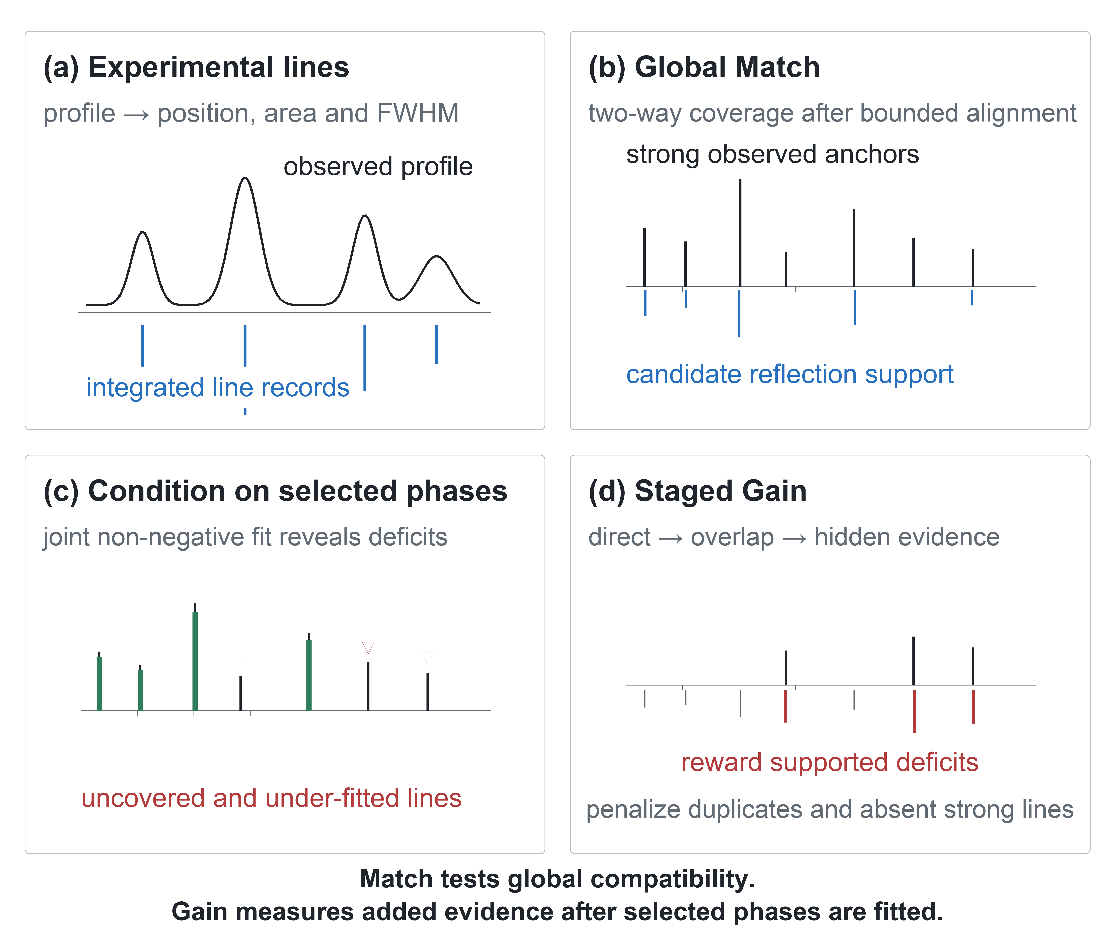
- Current Match and Gain logic. (a) The observed profile is converted into line records with position, integrated area and FWHM. (b) Match combines coverage of the strongest observed anchors with support of the candidate's strong reflections after bounded alignment. (c) Accepted phase profiles are fitted jointly, exposing uncovered lines and measurable deficits at shared reflections. (d) Gain requires multiple supported lines, rejects unsupported testable reflections and checks whether the candidate profile improves the residual model.
  - Semi-quantitative phase contributions
After phases have been accepted, their calculated profiles are fitted simultaneously to the active experimental signal by weighted non-negative least squares (Lawson & Hanson, 1995). The resulting non-negative coefficients are normalized across the selected phase set and displayed as Quant. (%). They are reported as semi-quantitative profile contributions. The current normalization does not correct for absorption, microabsorption, preferred orientation or phase-specific diffraction response. I/Ic is displayed separately and is not used in this normalization.
  - Reproducibility and software availability
Source code and tagged releases are available at https://github.com/ABKuznetsov/XRD_Analysis_Toolkit under the MIT licence. The repository contains the application code, release-building scripts and platform-specific packaging. A release used in a publication should be archived with a persistent DOI, and benchmark input patterns, expected phase labels and analysis settings should be deposited separately under an open licence. Database records remain subject to the terms and citations of their original providers.
- Evaluation design
  - Position relative to existing software
COD access and structure display are already available in established software. QUALX2.0 (Altomare et al., 2015) and iQual (Lv et al., 2024) provide efficient peak-based searches of COD-derived collections. Full-profile search–match (Lutterotti et al., 2019) and FullProfAPP (Arcelus et al., 2024) add profile-based testing and automated refinement, and XMatcher (Cao, 2026) offers an open comparison based on explicit peak evidence. Commercial packages cover a still broader range: Match! combines peak and profile-fitting searches with a COD-derived reference database (Putz & Brandenburg, 2024); HighScore links phase identification to profile and Rietveld analysis (Degen et al., 2014); JADE combines phase identification with whole-pattern fitting (International Centre for Diffraction Data, 2026); DIFFRAC.EVA 8 includes iterative Profile Fit Residual Search (Bruker, 2026); and STOE SEARCH/MATCH 2 combines COD searching with background correction, peak processing and profile fitting (STOE & Cie GmbH, 2026).
The useful comparison is therefore the complete workflow rather than a single feature. XRD Phase Finder combines open-source distribution, candidate generation from several experimental and computational repositories (Gražulis et al., 2009; Gražulis et al., 2012; Jain et al., 2013; Curtarolo et al., 2012; Saal et al., 2013; Lafuente et al., 2015), direct CIF input, visible peak-level and residual evidence, persistent projects, and Gain ranking after accepted phases have been fitted. The evaluation below compares Gain with internal Match-only and residual-ranking baselines. Published open and commercial programs (Altomare et al., 2015; Lv et al., 2024; Lutterotti et al., 2019; Arcelus et al., 2024; Cao, 2026; Putz & Brandenburg, 2024; Degen et al., 2014; International Centre for Diffraction Data, 2026; Bruker, 2026; STOE & Cie GmbH, 2026) are used to position the workflow, not as numerical benchmarks. A direct comparison would require matched database snapshots and reproducible access to the same licensed reference data.
A comparison between programs is meaningful only when chemical constraints and candidate availability are held constant. A missing database entry is a coverage failure, not a ranking failure. Calculated structures must also be distinguished from experimental references because relaxed lattice parameters and calculated relative intensities carry different uncertainties. For these reasons, the present benchmark is not a league table of search–match programs. Its narrower aim is to determine whether this implementation produces stable shortlists, suppresses unsupported residual additions and leaves enough graphical evidence for the user to judge the result. Database snapshots, preprocessing, sample texture, peak overlap and background treatment are reported because each can change the outcome.
  - Validation datasets and metrics
- Validation matrix for the version 1.2.2 Match and Gain implementation. The tests use a closed-world synthetic candidate pool and therefore measure controlled ranking behaviour, not universal identification accuracy or mass-fraction detection limits.
Validation block | Current test material | Current result | Interpretation
Closed-world corpus | 50 synthetic profiles (20 single, 20 binary, 10 ternary); 51 COD entries in 23 families | Shift, broadening, background, noise and overlap | Closed-world ranking test; not a real-sample accuracy estimate.
Dominant-phase Match | All 50 synthetic profiles | Dominant family: top-1 = 48/50; top-5 = 50/50 | The dominant family was shortlisted in every case; two top-1 errors.
Mixture completeness | All expected families in the 30 multiphase profiles | All true families: Match top-5 = 39/50; top-10 = 45/50 | Global Match initializes the search but does not recover every component.
Conditional Gain | 40 expected phase-addition steps from the binary and ternary profiles | Expected family: top-1 = 23/40; top-5 = 31/40; positive Gain = 31/40 | The conservative residual ranking promoted most true additions but rejected some weak or strongly overlapping components.
False additions | 20 closed single-phase profiles | False Gain ≥5% = 0/20; median maximum false Gain = 0.09% | No threshold-crossing false addition occurred in this closed test set.
Noise-significance stress test | 40 binary profiles and 10 negative controls | Gain top-5 by secondary-line SNR: 4/13 (<2), 1/11 (2–3), 2/7 (3–5), 3/9 (≥5); false Gain ≥5%: 0/10 controls; maximum false Gain = 1.43% | SNR alone did not determine rank because Gain also requires consistent multi-line evidence and penalizes unsupported reflections.

- Results and discussion
  - Interactive evidence workspace
The main window keeps the experimental pattern, candidate table, element filters, selected phases, structure card and database controls in view. The plot can display raw and processed signals, calculated profiles, reflection markers, the fitted total, background components, a difference curve and unexplained-line markers. Selecting a candidate updates its preview without running the database search again. The examples in this paper include competing COD entries for Ca₂Al₂SiO₇, a natural gehlenite sample in which grossular appears in the residual search, a broad low-intensity pattern that requires separate treatment of background and amorphous scattering, and a stick pattern loaded directly from a user CIF.
The database layer is intentionally separated by material class. Organic and inorganic records can be searched independently, which is important because organic molecular crystals often have different indexing ambiguity, preferred-orientation behaviour and metadata expectations from mineral or catalyst phases. The card panel preserves both sample-level and reference-level information: sample name, source file, measurement axes and processing state are shown separately from reference provenance, I/Ic, quality flag, space group, unit-cell parameters, atomic coordinates and diffraction-line tables. This separation is useful for publication and reporting because a candidate assignment can be traced back to the exact database entry or user CIF rather than only to a displayed phase name.
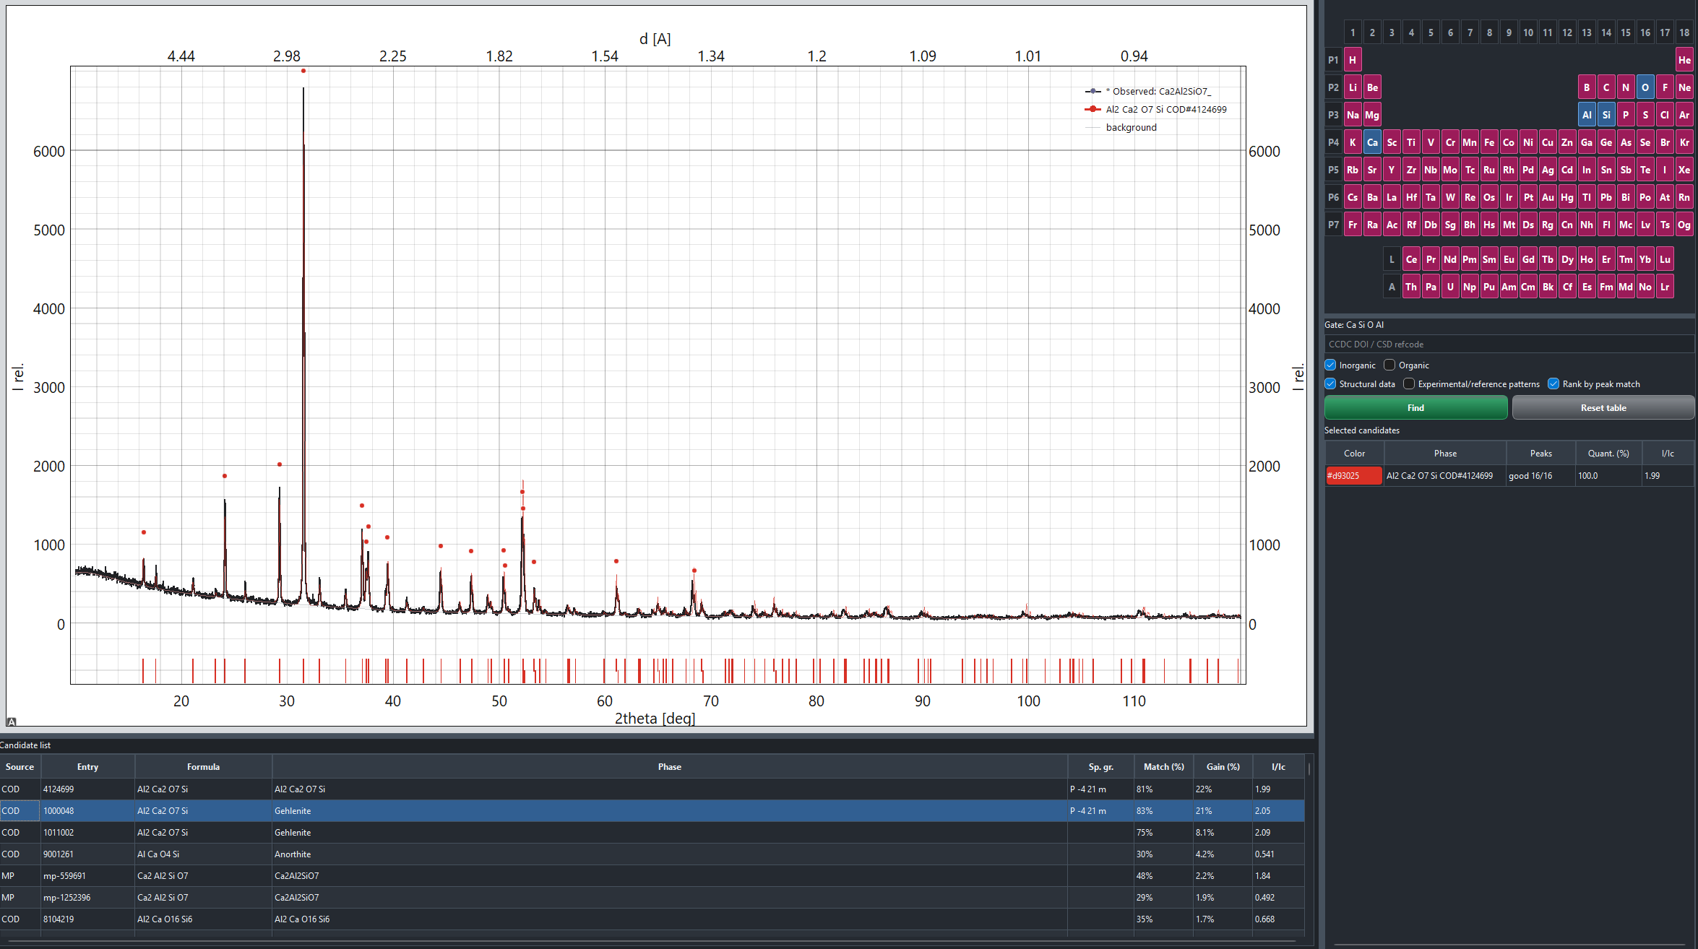
- Main XRD Phase Finder workspace. The central plot combines experimental and calculated evidence; candidate and selected-phase tables remain visible so that ranking decisions can be inspected in context.
  - Dominant-phase ranking
Before any phase is accepted, the list is ordered by Match and the Gain column is intentionally left empty. The first pass is intended to recover a plausible dominant family without requiring every experimental line to belong to it. In the Ca2Al2SiO7 example, several COD entries have closely related chemistry and diffraction evidence. The ranking alone does not establish which entry best represents the sample. The user can compare source provenance, leading-reflection coverage and strong calculated lines that are absent from the experiment; one coincident maximum is not sufficient.
- Dominant-phase identification example. Closely related calcium aluminosilicate entries are ordered by Match before any phase is accepted. The plot and candidate table expose both supporting lines and strong calculated reflections absent from the experiment. Gain is intentionally left empty at this stage.
  - Residual ranking in multiphase patterns
Once a dominant phase is accepted, the ordering changes from overall resemblance to additional explanatory value. This is useful when several database entries describe the same structure family or when a minor phase shares its strongest reflection with an accepted phase. In the natural gehlenite example, accepting the principal candidate removes much of the common diffraction evidence from the next search. A related candidate is promoted only when it also supports residual lines or a reproducible under-fit at shared reflections. The example illustrates the intended workflow; the benchmark below tests the ranking behaviour independently of that specimen.
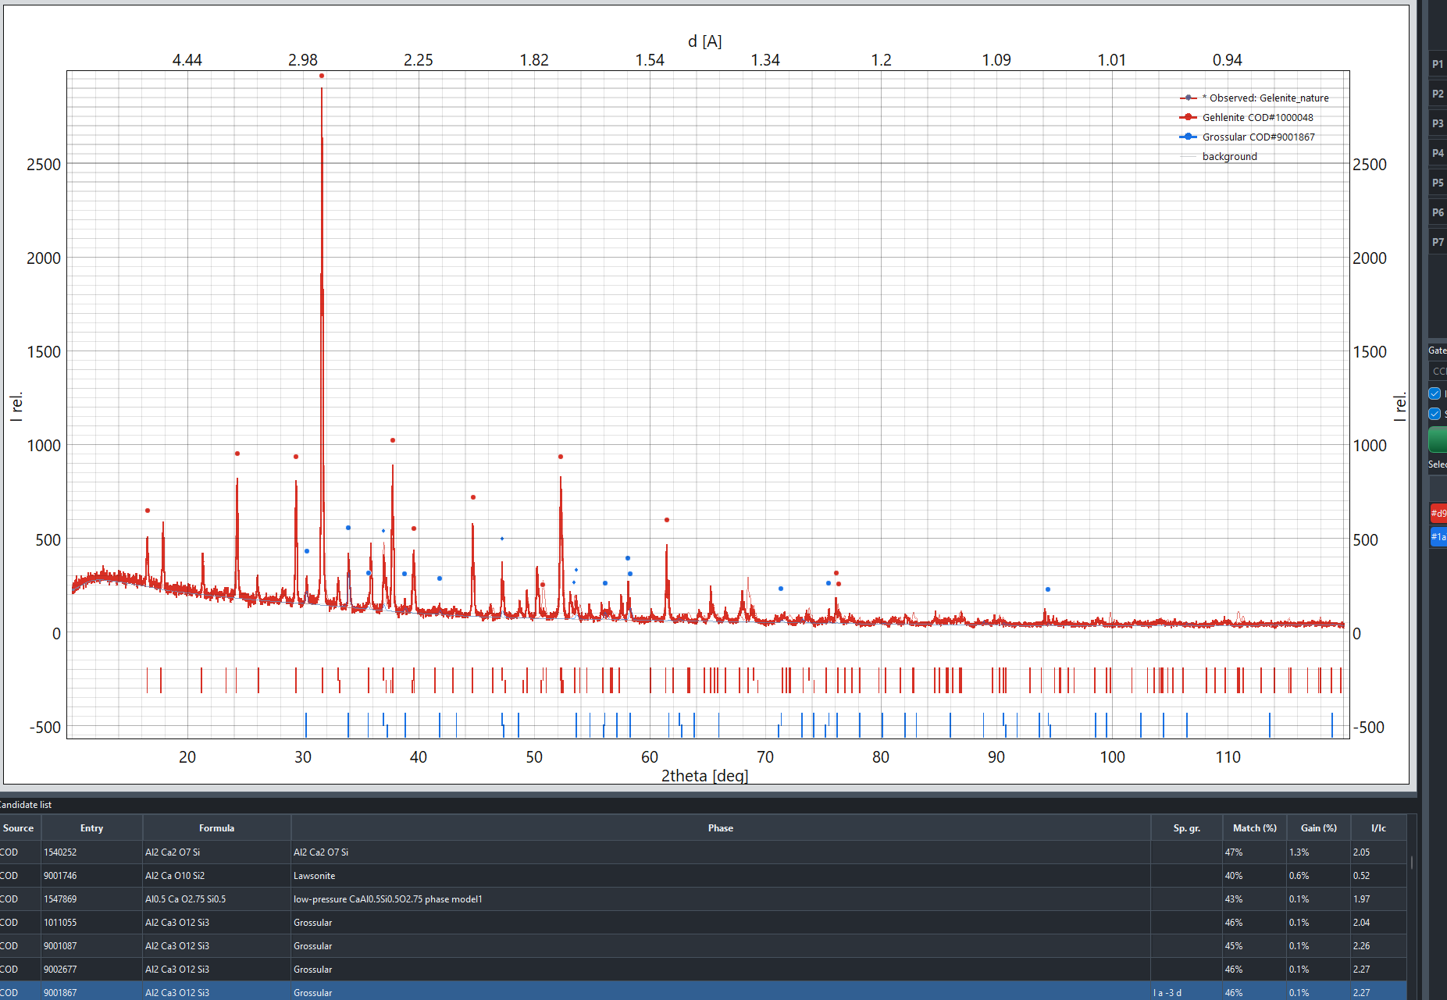
- Effect of conditional residual ranking. After the dominant candidate is accepted and the selected-phase model is refitted, Gain reorders the remaining entries according to additional residual evidence. Structurally related candidates that mainly repeat explained lines are demoted, while candidates supporting coherent unexplained lines remain visible for inspection.
  - Version 1.2.2 closed-world validation
The version 1.2.2 implementation was evaluated on 50 synthetic profiles generated from 23 representative COD formula families. The candidate pool contained 51 COD entries belonging to the same 23 families and therefore included the expected answer for every case. The set comprised 20 single-phase, 20 binary and 10 ternary profiles with controlled angular shifts, line broadening, background, noise and peak overlap. This closed-world design separates ranking behaviour from database-coverage failure, but it does not reproduce all instrumental and specimen effects found in laboratory data.
For the dominant phase, exact COD entry retrieval reached top-1 in 47/50 cases and top-5 in 50/50. When crystallographically related entries were grouped by formula family, the dominant family ranked first in 48/50 cases and appeared in the top five in all 50. Across the complete mixtures, all expected families were present in the Match top five in 39/50 cases and in the top ten in 45/50. Match is therefore most reliable as an initial dominant-phase shortlist, not as a complete one-pass decomposition of a mixture.
Conditional Gain was evaluated over 40 expected phase-addition steps from the binary and ternary profiles. After the accepted families were fitted, the next expected family ranked first by Gain in 23/40 steps and appeared in the top five in 31/40; it received positive Gain in 31/40. The version 1.2.2 evidence gates are deliberately conservative: they reduce unsupported additions, but they also reject some weak or strongly overlapping true components. Gain should therefore be read as a residual shortlist rather than as an exhaustive detector.
The same benchmark included 20 closed single-phase profiles for which any additional family was false. None produced a false Gain of at least 5%, and the median maximum false Gain was 0.09%. In this controlled candidate pool, the multiple-line, missing-line and profile-improvement gates prevented threshold-crossing false additions. This result describes the closed test set and should not be interpreted as a universal false-positive rate.
A separate noise-significance stress test contained 40 binary profiles and ten single-phase negative controls. The signal-to-noise ratio was defined as the height of the second-strongest true minor-phase line divided by the known pointwise Gaussian-plus-counting noise standard deviation. The expected family appeared in the Gain top five in 4/13 cases below SNR 2, 1/11 cases at SNR 2–3, 2/7 cases at SNR 3–5 and 3/9 cases at SNR ≥5. Two of the nine SNR ≥5 cases ranked first. None of the ten negative controls produced Gain above 5%; the maximum false Gain was 1.43%.
Table 2 summarizes both tests. Recovery did not increase monotonically with this single-line SNR measure. The three-sigma threshold determines whether an individual reflection is testable, whereas Gain also requires several consistent lines, penalizes unsupported calculated reflections and accounts for overlap with accepted phases. SNR alone therefore does not determine the rank of a minor phase. The reported percentages describe ranking positions and fitted profile contributions, not mass detection limits. Validation on independently interpreted laboratory mixtures remains necessary.
  - Ablation of residual ranking
The four ranking modes were compared on the same 40 conditional phase-addition steps. Original Match retained the full-pattern ranking after accepted families were excluded. Residual Match repeated Match on peaks detected in the positive residual. Production Gain added the multi-line evidence gate, profile-improvement test and unsupported-line penalties. Raw Gain measured residual profile coverage without these safeguards.
- Ablation of conditional ranking in version 1.2.2. Top-k and mean reciprocal rank (MRR) refer to the next expected formula family. False-addition counts use the 20 closed single-phase controls; Match scores do not have a directly comparable automatic acceptance threshold.
Mode | Ranking result | Acceptance behaviour | Interpretation
Original Match | Top-1 = 15/40; top-5 = 31/40; MRR = 0.541 | No comparable Gain threshold | Global ranking provides the baseline after accepted families are excluded.
Residual Match | Top-1 = 30/40; top-5 = 37/40; MRR = 0.809 | No comparable Gain threshold | Residual peak ranking gave the strongest shortlist in this closed test.
Production Gain | Top-1 = 23/40; top-5 = 31/40; MRR = 0.653 | Positive = 31/40; false ≥5% = 0/20 | Evidence gates traded sensitivity for specificity.
Raw Gain | Top-1 = 29/40; top-5 = 35/40; MRR = 0.794 | Positive = 38/40; false ≥5% = 14/20 | Removing gates recovered more true additions but admitted many false ones.
Residual Match produced the best top-five recovery, whereas production Gain was more selective. Removing the Gain gates restored much of the ranking sensitivity but produced a score of at least 5% in 14 of 20 single-phase controls. The ablation therefore does not show that Gain dominates every residual-ranking baseline. It shows the purpose of the current Gain design: to attach an explicit penalty to unsupported additions while keeping the evidence visible for manual review.
  - Background, amorphous scattering and broad peaks
Background choice strongly affects catalyst and mineral patterns. A flexible baseline may climb into the shoulders of crystalline peaks, while a rigid exponential model may leave holder scattering or diffuse intensity in the residual. XRD Phase Finder therefore shows two estimates: the physical background and, when requested, the physical background plus a broad amorphous contribution. Both can be inspected before subtraction. In the IM-2202 example, the black curve is the physical background and the blue curve is the combined estimate. Their difference is treated as diffuse amorphous scattering, not as a selected crystalline phase.
Automatic processing selects parameters for the explicit smoothing and baseline models described above. It cannot uniquely separate instrumental background, amorphous material and nanocrystalline broadening in every pattern. Validation must therefore include low-angle holder scattering, diffuse halos, narrow and broad crystalline peaks, negative detector values and overlapping phases. A useful setting should preserve peak area and phase ordering; a visually flat residual is not sufficient.
  - Limitations
Phase identification cannot succeed when the relevant structure or reference pattern is absent from the candidate pool. Closely related polymorphs, solid solutions and structures with similar unit cells may remain ambiguous. Calculated intensities can disagree with experiment because of preferred orientation, absorption, texture, site occupancy, radiation choice and incomplete structural models. Bounded zero and scale corrections improve robust ranking but do not constitute lattice refinement. Match and Gain should therefore guide inspection; they must not be reported as statistical confidence or mass percentage.
The selected-phase table provides a semi-quantitative estimate by normalizing non-negative fitted profile contributions. The values are useful for comparing accepted phases within the current model, but they are not validated mass fractions because absorption, microabsorption, preferred orientation and phase-specific diffraction response are not fully corrected.
- Conclusions
XRD Phase Finder is a cross-platform, open-source workspace for interpreting which crystalline phases are present in a powder mixture. It supports both an automatic search and a semi-automatic workflow in which the user reviews and accepts phases between iterations. COD access by itself is not new. The contribution of the program is the combination of several open structure sources, direct CIF input and an iterative search whose evidence remains visible. Match tests global two-way agreement between observed anchors and candidate reflections. After a phase is accepted, staged Gain asks what another candidate adds through uncovered, under-fitted overlapping or hidden-phase evidence. The selected-phase fit also provides a clearly labelled semi-quantitative estimate from normalized non-negative profile contributions. Supporting and conflicting lines, processing choices and the current phase model remain part of the saved project.
In the version 1.2.2 closed-world benchmark, Match placed the dominant formula family first in 48 of 50 profiles and within the top five in all 50. Conditional Gain placed the next expected family in the top five in 31 of 40 phase-addition steps. No Gain of at least 5% was produced for the 20 closed single-phase profiles or the ten negative controls. These results support the intended use of the program as an inspectable automatic or semi-automatic phase-hypothesis tool, with a conservative residual search that favors specificity over exhaustive recovery of weak components. They do not establish universal accuracy, analytical detection limits or quantitative mass fractions. Independent laboratory evaluation and an archived database snapshot remain the next validation steps.
Funding information
This work was supported by the state assignment of the Sobolev Institute of Geology and Mineralogy, Siberian Branch of the Russian Academy of Sciences (No. FWZN-2026-0014).
Generative artificial-intelligence tools were used for language editing and schematic layout. The author checked all scientific statements, numerical results, source citations and final wording.
Author contributions
A. B. Kuznetsov: conceptualization, methodology, software, validation, investigation, visualization, writing and project administration.
The author declares no conflict of interest.
The source code and release packages are available at https://github.com/ABKuznetsov/XRD_Analysis_Toolkit. The exact version used for the reported evaluation, the synthetic benchmark patterns, expected family labels, generation settings and tabulated Match/Gain results will be archived in a persistent repository before submission. Complete third-party structure collections are not bundled with the platform installers. Reproduction must therefore report the database snapshot or archived candidate list used for the run. Individual CIF files can be evaluated directly without inclusion in a shared database.

References
Altomare, A., Corriero, N., Cuocci, C., Falcicchio, A., Moliterni, A. & Rizzi, R. (2015). QUALX2.0: a qualitative phase analysis software using the freely available database POW_COD. J. Appl. Cryst. 48, 598–603. https://doi.org/10.1107/S1600576715002319. Software: https://www.ba.ic.cnr.it/softwareic/qualxweb/.
Arcelus, O. et al. (2024). FullProfAPP: a graphical user interface for the streamlined automation of powder diffraction data analysis. J. Appl. Cryst. 57, 1676–1690. https://doi.org/10.1107/S1600576724006885.
Baek, S.-J., Park, A., Ahn, Y.-J. & Choo, J. (2015). Baseline correction using asymmetrically reweighted penalized least squares smoothing. Analyst 140, 250–257. https://doi.org/10.1039/C4AN01061B.
Bruker (2026). DIFFRAC.EVA 8: XRD evaluation software and Profile Fit Residual Search. https://www.bruker.com/en/products-and-solutions/diffractometers-and-x-ray-microscopes/x-ray-diffractometers/diffrac-suite-software/diffrac-eva.html (accessed 25 July 2026).
Cao, B. (2026). XMatcher: an open-source framework for X-ray diffraction phase identification. arXiv:2607.17162. https://arxiv.org/abs/2607.17162.
Coelho, A. A. (2018). TOPAS and TOPAS-Academic: an optimization program integrating computer algebra and crystallographic objects written in C++. J. Appl. Cryst. 51, 210–218. https://doi.org/10.1107/S1600576718000183.
Cromer, D. T. & Mann, J. B. (1968). X-ray scattering factors computed from numerical Hartree–Fock wave functions. Acta Cryst. A24, 321–324. https://doi.org/10.1107/S0567739468000550.
Curtarolo, S. et al. (2012). AFLOW: an automatic framework for high-throughput materials discovery. Comput. Mater. Sci. 58, 218–226. https://doi.org/10.1016/j.commatsci.2012.02.005. Resource: https://aflow.org/.
Degen, T., Sadki, M., Bron, E., König, U. & Nénert, G. (2014). The HighScore suite. Powder Diffr. 29(S2), S13–S18. https://doi.org/10.1017/S0885715614000840.
Dinnebier, R. E. & Billinge, S. J. L. (eds.) (2008). Powder Diffraction: Theory and Practice. Cambridge: Royal Society of Chemistry.
Eilers, P. H. C. & Boelens, H. F. M. (2005). Baseline correction with asymmetric least squares smoothing. Leiden University Medical Centre Report.
Erb, D. (2022). pybaselines: a Python library of algorithms for the baseline correction of experimental data. https://doi.org/10.5281/zenodo.5608581.
Gilmore, C. J., Kaduk, J. A. & Schenk, H. (eds.) (2019). International Tables for Crystallography, Vol. H: Powder Diffraction. Chester: International Union of Crystallography. https://doi.org/10.1107/97809553602060000115.
Gražulis, S. et al. (2009). Crystallography Open Database — an open-access collection of crystal structures. J. Appl. Cryst. 42, 726–729. https://doi.org/10.1107/S0021889809016690.
Gražulis, S. et al. (2012). Crystallography Open Database (COD): an open-access collection of crystal structures and platform for world-wide collaboration. Nucleic Acids Res. 40, D420–D427. https://doi.org/10.1093/nar/gkr900. Resource: https://www.crystallography.net/cod/.
Harris, C. R. et al. (2020). Array programming with NumPy. Nature 585, 357–362. https://doi.org/10.1038/s41586-020-2649-2.
Hunter, J. D. (2007). Matplotlib: a 2D graphics environment. Comput. Sci. Eng. 9, 90–95. https://doi.org/10.1109/MCSE.2007.55.
International Centre for Diffraction Data (2026). JADE XRD software: phase identification and whole-pattern fitting. https://www.icdd.com/mdi-jade/ (accessed 25 July 2026).
Jain, A. et al. (2013). Commentary: The Materials Project: a materials genome approach to accelerating materials innovation. APL Mater. 1, 011002. https://doi.org/10.1063/1.4812323. Resource: https://materialsproject.org/.
Lafuente, B., Downs, R. T., Yang, H. & Stone, N. (2015). The power of databases: the RRUFF project. In Highlights in Mineralogical Crystallography, edited by T. Armbruster & R. M. Danisi, pp. 1–30. Berlin: De Gruyter. https://doi.org/10.1515/9783110417104-003. Resource: https://rruff.info/.
Larsen, A. H. et al. (2017). The Atomic Simulation Environment — a Python library for working with atoms. J. Phys. Condens. Matter 29, 273002. https://doi.org/10.1088/1361-648X/aa680e.
Lawson, C. L. & Hanson, R. J. (1995). Solving Least Squares Problems. Philadelphia: Society for Industrial and Applied Mathematics. https://doi.org/10.1137/1.9781611971217.
Lutterotti, L., Pillière, H., Fontugne, C., Boullay, P. & Chateigner, D. (2019). Full-profile search–match by the Rietveld method. J. Appl. Cryst. 52, 587–598. https://doi.org/10.1107/S160057671900342X.
Lv, B., Feng, Z., Sun, X., Cao, J., Gao, Y., Chang, S., Dong, C. & Zhang, J. (2024). iQual: a new computer program for qualitative phase analysis with efficient search–match capability. J. Appl. Cryst. 57, 572–579. https://doi.org/10.1107/S1600576724002267.
Macrae, C. F. et al. (2008). Mercury CSD 2.0 — new features for the visualization and investigation of crystal structures. J. Appl. Cryst. 41, 466–470. https://doi.org/10.1107/S0021889807067908.
McKinney, W. (2010). Data structures for statistical computing in Python. Proc. 9th Python in Science Conference, 56–61. https://doi.org/10.25080/Majora-92bf1922-00a.
Momma, K. & Izumi, F. (2011). VESTA 3 for three-dimensional visualization of crystal, volumetric and morphology data. J. Appl. Cryst. 44, 1272–1276. https://doi.org/10.1107/S0021889811038970.
Morháč, M., Kliman, J., Matoušek, V., Veselský, M. & Turzo, I. (1997). Background elimination methods for multidimensional coincidence gamma-ray spectra. Nucl. Instrum. Methods Phys. Res. A 401, 113–132. https://doi.org/10.1016/S0168-9002(97)01023-1.
Ong, S. P. et al. (2013). Python Materials Genomics (pymatgen): a robust, open-source Python library for materials analysis. Comput. Mater. Sci. 68, 314–319. https://doi.org/10.1016/j.commatsci.2012.10.028.
Putz, H. & Brandenburg, K. (2024). Match! — Phase Analysis using Powder Diffraction. Crystal Impact, Bonn, Germany. https://www.crystalimpact.com/match/.
Rodríguez-Carvajal, J. (1993). Recent advances in magnetic structure determination by neutron powder diffraction. Physica B 192, 55–69. https://doi.org/10.1016/0921-4526(93)90108-I.
Saal, J. E., Kirklin, S., Aykol, M., Meredig, B. & Wolverton, C. (2013). Materials design and discovery with high-throughput density functional theory: the Open Quantum Materials Database (OQMD). JOM 65, 1501–1509. https://doi.org/10.1007/s11837-013-0755-4. Resource: https://oqmd.org/.
Savitzky, A. & Golay, M. J. E. (1964). Smoothing and differentiation of data by simplified least squares procedures. Anal. Chem. 36, 1627–1639. https://doi.org/10.1021/ac60214a047.
Schwarz, G. (1978). Estimating the dimension of a model. Ann. Stat. 6, 461–464. https://doi.org/10.1214/aos/1176344136.
STOE & Cie GmbH (2026). The new STOE SEARCH/MATCH 2. https://www.stoe.com/articles/new-search-match-2-appnote/ (accessed 25 July 2026).
The Qt Company (2026). Qt for Python (PySide6) documentation. https://doc.qt.io/qtforpython-6/ (accessed 25 July 2026).
Thompson, P., Cox, D. E. & Hastings, J. B. (1987). Rietveld refinement of Debye–Scherrer synchrotron X-ray data from Al2O3. J. Appl. Cryst. 20, 79–83. https://doi.org/10.1107/S0021889887087090.
Toby, B. H. & Von Dreele, R. B. (2013). GSAS-II: the genesis of a modern open-source all-purpose crystallography software package. J. Appl. Cryst. 46, 544–549. https://doi.org/10.1107/S0021889813003531.
Togo, A., Shinohara, K. & Tanaka, I. (2024). Spglib: a software library for crystal symmetry search. Sci. Technol. Adv. Mater. Methods 4, 2384822. https://doi.org/10.1080/27660400.2024.2384822.
Virtanen, P. et al. (2020). SciPy 1.0: fundamental algorithms for scientific computing in Python. Nat. Methods 17, 261–272. https://doi.org/10.1038/s41592-019-0686-2.
Wojdyr, M. (2022). GEMMI: a library for structural biology. J. Open Source Softw. 7, 4200. https://doi.org/10.21105/joss.04200.

